Fuel economy visual analysis (R / ggplot2)

Problem Statement
EPA/DOE vehicles.csv lists every US-market configuration since 1984 with combined, city, and highway MPG plus engine, transmission, fuel, and make. The Cookbook Ch. 2 question is simple: did fuel economy actually improve, or did the mix of vehicles change? An all-rows mean after 2011 is inflated by hybrids and EVs (MPGe). Decision-makers need a gasoline-only series, a size-vs-MPG check, and a make-level view — in R, with charts a mixed audience can skim.

Solution Strategy
Follow the data-science pipeline in the chapter: acquire → import with stringsAsFactors = FALSE → explore nrow/ncol/year/fuel tables → repair trany and charger types → split–apply–combine year means (dplyr or plyr) → ggplot2 point+smooth → subset gasoline → relate displacement to MPG → melt/facet dual series → 4-cyl boxplots and transmission mix → Reduce(intersect) for makes present every year 1984–2014 → Monte-Carlo-style knobs (year cut, hybrids on/off, noise, subsample). Write four audience versions of the same finding.

Solution
This extract: 50,242 rows × 84 columns, years 1984–2027. Regular gasoline 31,324; Premium 15,759; Electricity 1,572. Auto 36,934 / Manual 13,297. All-vehicle mean combined MPG: 19.88 (1984) → 23.55 (2014) → 37.38 (2024). Gasoline-only (no hybrid/dual-fuel/EV): 19.12 → 19.19 (2008) → 22.27 (2014) → 22.09 (2024). Mean displacement peaked ~3.59 L in 2008 then eased to ~3.12 L. displ vs comb08 r ≈ −0.78. Twelve 4-cyl makes appear every year 1984–2014 (same list as the book). 4-cyl Auto share 42% → 91%.
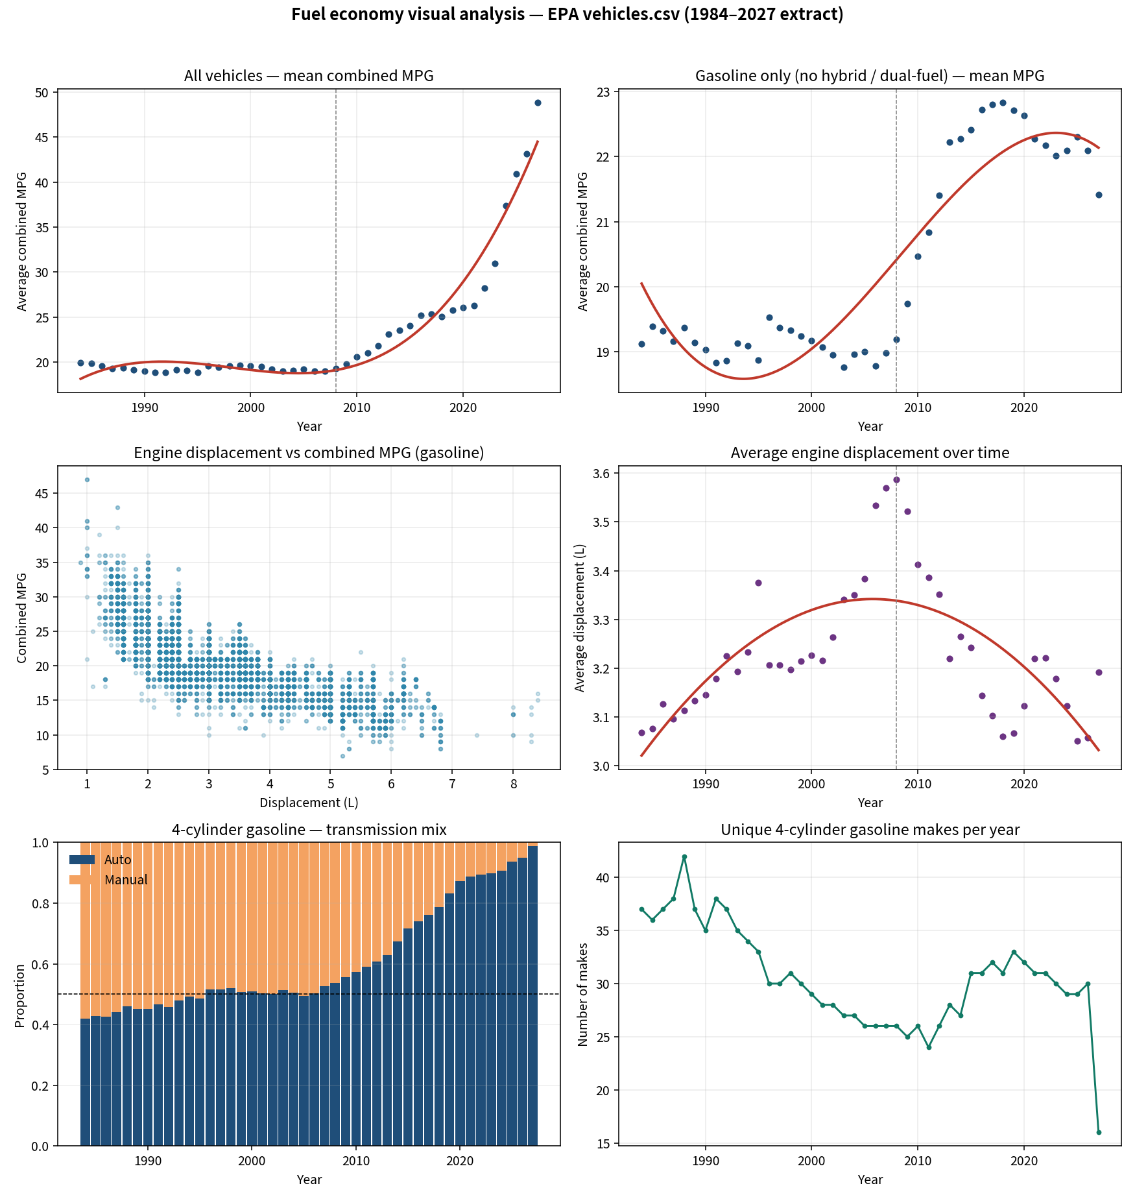
Figure. All-fleet vs gasoline-only MPG, displacement scatter and time series, 4-cyl transmission mix, unique makes. The red all-fleet line after 2011 is not an ICE story.

Key Takeaways
- Never brief the pooled MPG series without naming EVs/hybrids. Gasoline-only improved after 2008, not in a straight line from 1984.
- Smaller engines explain part of the post-2008 gasoline gain; efficiency at a given size also improved (MPG flat while displacement rose until 2005).
- Manuals are no longer the high-MPG niche they were; the catalog itself became automatic.
- Type traps (blank trany, charger flags, factor import) belong in the lab notebook before the chart.
- Short project name: FuelEcon_R. Practice in the skeleton; answers in the solution; reuse via the template.

